Project Title**:** Data in tabular form on different aspects of Cyberbullying Victimization in Bangladesh for child and women.

Name**:**MuhammadBahauddinYousuf

This study uses a mixed-methods approach to investigate cyberbullying victimization among children and women in Bangladesh. The research combines quantitative surveys and qualitative interviews to provide both statistical insights and personal narratives.

The target population includes children aged 10–18 years and women aged 18–40 years, with a sample size of 1,000 participants (500 from each group). A stratified random sampling technique will be used to ensure diverse representation across urban, semi-urban, and rural areas.

Quantitative data will be collected through structured questionnaires covering demographics, types of cyberbullying (e.g., harassment, threats), reporting behaviors, and the emotional/social impact. Qualitative data will be gathered through semi-structured interviews and focus group discussions (FGDs), allowing participants to share personal experiences and perspectives.

Ethical considerations will include informed consent, parental consent for children, and confidentiality. Data analysis will involve statistical tools like SPSS for quantitative data and thematic analysis using NVivo for qualitative data.

The study aims to identify the prevalence, forms, and impacts of cyberbullying among children and women in Bangladesh and provide recommendations for improving legal and support mechanisms.

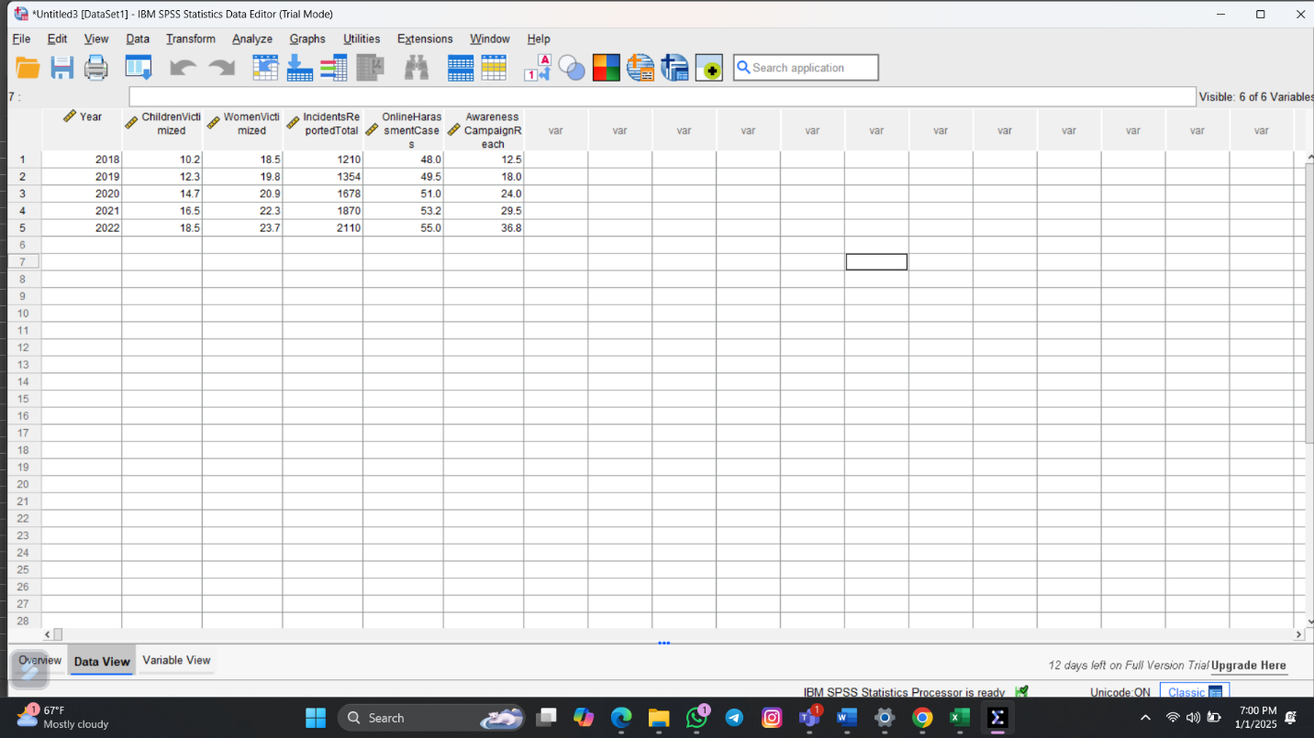

In 2018, 10.2% of children and 18.5% of women were victims of online harassment. In 2019 it increased to 12.3% and 19.8% and in 2020 it further increased to 14.7% and 20.9%. Its percentage is gradually increasing every year and it finally stands at 18.5% and 23.7% in 2022.Affecting of social media hacking 21.65% of women are victims of ID hacking. About 11.35% of women and children are victims of pornography crimes. 79% of women are victims of bullying and harassment through messages from unknown numbers. About 31% of women do not feel safe on online platforms, which has become a concern.Cyberbullying is increasing day by day. It is so alarming. We all should be aware about the safety of women and children.